

EMAIL SIGNATURE TEMPLATE

FOR WINDOWS SYSTEMS
omancables.com

HOW TO SET IT UP?

STEP 1:
Copy the below email signature.

Full Name
Job Description
M.+968 1234 5678, T.+968 1234 5678


STEP 2:
- Open the Outlook application and click on New Email
- When a New Email window pop-up, navigate to Signature > Signatures
- Under Select signature to edit field, click on New
- Type in the name for the signature and click on OK
- Once a signature is created, you may edit it in the field below and set as a default for New Emails and/or Replies and Forwards
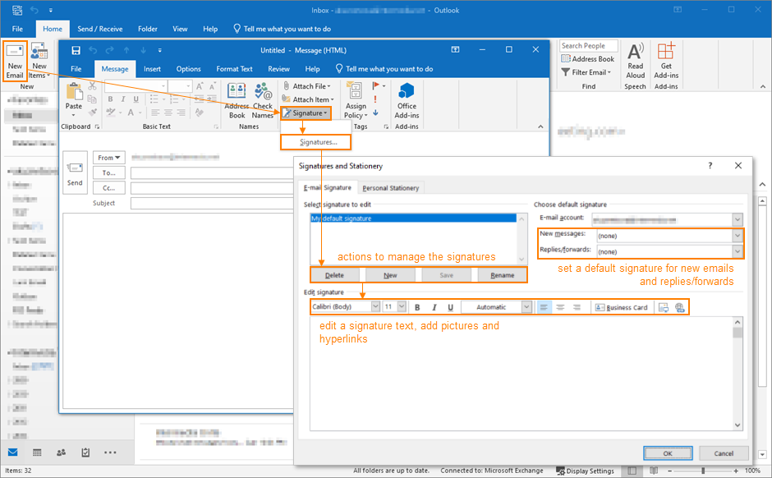

STEP 3:
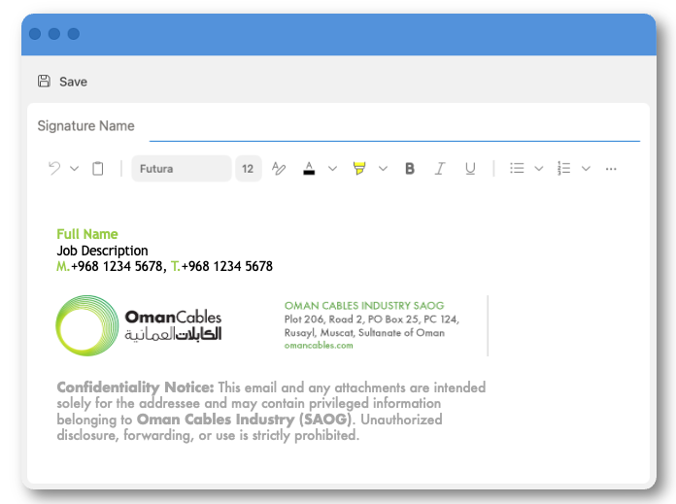
And you’re done!
Your new email signature is ready to use.

